SCAR RELEASE THERAPY

FREE presentation With Juliet Mathison, Specialized Kinesiologist

**Tuesday April 5, 2016 7:00 – 8:00 pm plus Q&A**

**Integrated Healing Arts, 1718 Main St. Suite 310 Sarasota FL 34236**

**To reserve your seat RSVP to (941) 356-7768 integratedhealingartsbodywork.com**

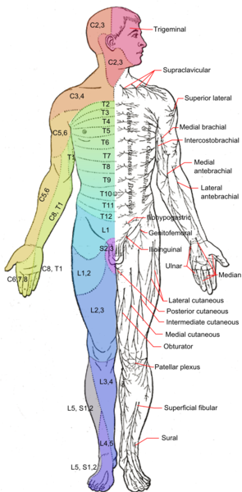

**DID YOU KNOW** that a scar on one part of the body can cause pain somewhere else, or organ dysfunction and subsequent illness?

***A scar*** is often the hidden culprit in mystery illnesses or unresolved pain patterns that have not responded to conventional treatments.

Some of the most common examples include:

C-section scars – back pain, kidney problems

Breast surgery – heart and digestive issues

Scars on the arms, hands, legs and feet – back pain, neck pain, digestive problems, urinary and reproductive issues & respiratory distress.

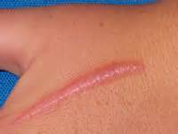

Trauma and surgery cuts through muscles, nerves, connective tissue and acupuncture meridians. Both organ function and the structural integrity of the musculoskeletal system can be significantly compromised. Bio-compatible therapeutic micro-current is used to correct de-polarized scar tissue, release constricted connective tissue, relieve pain and restore meridian flow to the affected organ(s). Physical appearance of scars can also be reduced and scar sensitivity minimized.

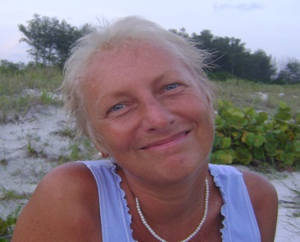

Juliet Mathison, Specialized Kinesiologist, trained in Micro-current Scar Release Therapy directly under Dr. Bruce Hocking, developer of the technique. Juliet has over 25 years’ experience providing pain relief and rehabilitation from injury, surgery or trauma of any kind. Juliet’s work is 100% satisfaction guaranteed. Expect results.

**(770) 465-6294 LifeSpectrumInstitute.com**